

CSA1109-Object Oriented Analysis and Design

CO-4 AT -3

Reverse Engineering Task

Ashmi P S
192571004

1.Railway Reservation and Scheduling System
Introduction:
The Railway Reservation and Scheduling System is a legacy system used to manage train schedules, routes, passenger registration, seat allocation, ticket booking, ticket cancellation, fare calculation, and reservation status. The existing system is tightly coupled, meaning that changes made to one functionality may require modifications in several other modules.
Reverse engineering is used to understand the existing system by identifying its major components, classes, attributes, operations, responsibilities, and relationships. The system is then redesigned using object-oriented principles and layered architecture to improve cohesion, reduce coupling, scalability, flexibility, and maintainability.

Understanding of the Existing System:
The major functionalities of the existing Railway Reservation System are:
- Passenger Registration – Stores passenger details such as passenger ID, name, age, gender, and contact information.
- Train Management – Maintains train number, train name, source, destination, and train type.
- Schedule Management – Maintains departure time, arrival time, travel date, and train availability.
- Route Management – Stores stations and the sequence of stations followed by a train.
- Seat Allocation – Checks available seats and allocates seats to passengers.
- Ticket Booking – Creates reservations and generates ticket details.
- Cancellation – Cancels booked tickets and releases allocated seats.
- Fare Calculation – Calculates fare based on distance, class, passenger type, and other applicable rules.
- Reservation Status – Maintains statuses such as Confirmed, RAC, Waiting List, and Cancelled.
- Payment Management – Handles payment details associated with ticket booking.
Problems in the Legacy System
- Modules are tightly coupled.
- Business logic and user interface are mixed together.
- Changes in fare calculation can affect booking and payment modules.
- Changes in train schedules may require modifications in multiple modules.
- Code duplication may occur.
- Testing individual components is difficult.
- Adding new features requires changes to existing code.
- The system has poor scalability and maintainability.

Reverse Engineering – Candidate Classes
The following candidate classes can be identified from the existing system.
Class | Important Attributes | Major Operations | Responsibility
Passenger | passengerId, name, age, gender, phone | register(), updateDetails() | Maintains passenger information
Train | trainNo, trainName, trainType | addTrain(), updateTrain() | Maintains train information
Schedule | scheduleId, date, departureTime, arrivalTime | createSchedule(), updateSchedule() | Manages train schedules
Route | routeId, source, destination, distance | addStation(), calculateDistance() | Manages train routes
Station | stationId, stationName, location | addStation(), updateStation() | Represents railway stations
Seat | seatNo, coachNo, classType, status | allocate(), release() | Manages seat availability
Reservation | reservationId, bookingDate, status | book(), cancel(), updateStatus() | Maintains reservation information
Ticket | ticketNo, fare, journeyDate | generateTicket(), printTicket() | Represents booked ticket
Fare | fareId, baseFare, distance, classType | calculateFare() | Calculates journey fare
Payment | paymentId, amount, method, status | makePayment(), refund() | Manages payment transactions
Cancellation | cancellationId, cancellationDate, refundAmount | cancelTicket(), calculateRefund() | Handles cancellation and refund
Admin | adminId, username | addTrain(), updateSchedule() | Manages system information

Class Responsibilities:
Passenger: The Passenger class stores passenger information and provides operations for registration and updating passenger details.
Train: The Train class manages train-related information such as train number, name, type, and available coaches.
Schedule: The Schedule class manages departure and arrival details for a particular train and travel date.
Route: The Route class maintains source, destination, stations, and distance information.
Seat: The Seat class maintains seat number, coach number, class type, and availability status. It performs seat allocation and release.
Reservation: The Reservation class represents a passenger's booking. It maintains reservation status and connects passengers, trains, seats, tickets, and payments.
Ticket: The Ticket class represents the generated ticket and contains ticket number, journey date, fare, and reservation information.
Fare: The Fare class calculates the fare based on distance, travel class, and applicable fare rules.
Payment: The Payment class handles payment processing, payment status, and refunds.
Cancellation: The Cancellation class handles ticket cancellation and calculates the applicable refund.

Relationships Between Classes
The major relationships are:
- Passenger → Reservation
One passenger can have multiple reservations.
- Train → Schedule
A train can have multiple schedules.
- Train → Route
A train follows a route.
- Route → Station
A route contains multiple stations.
- Reservation → Passenger
A reservation belongs to a passenger.
- Reservation → Train
A reservation is made for a particular train.
- Reservation → Seat
A reservation is assigned a seat.
- Reservation → Ticket
A successful reservation generates a ticket.
- Reservation → Payment
A reservation is associated with a payment.
- Ticket → Cancellation
A ticket may have a cancellation record.
- Fare → Reservation
Fare calculation is performed for a reservation.

Object-Oriented Redesign
The legacy system can be redesigned using the following object-oriented principles.
1. Encapsulation
Each class stores its own data and provides appropriate methods to access or modify it.
For example, the Seat class manages its own availability through:
- allocate()
- release()
This prevents other classes from directly modifying seat status.
2 .Abstraction
Complex operations such as fare calculation and payment processing are hidden behind simple methods.
For example:
Fare.calculateFare()
The reservation system does not need to know the internal calculation logic.
3.Inheritance
Common properties can be reused through inheritance.
For example:
Person
|---- Passenger
|---- Admin
Common attributes such as name and contact information can be maintained in the parent class.
4. Polymorphism
Different fare rules or payment methods can implement the same operation differently.
For example:
FareCalculator
|---- GeneralFareCalculator
|---- ACFirstClassFareCalculator
|---- SleeperFareCalculator
Each implementation can provide its own calculateFare() behavior.
5. Single Responsibility Principle
Each class should have one major responsibility.
For example:
- Passenger → passenger information
- Reservation → booking management
- Fare → fare calculation
- Payment → payment processing
- Schedule → schedule management
This makes the system easier to understand and modify.

UML Class Diagram
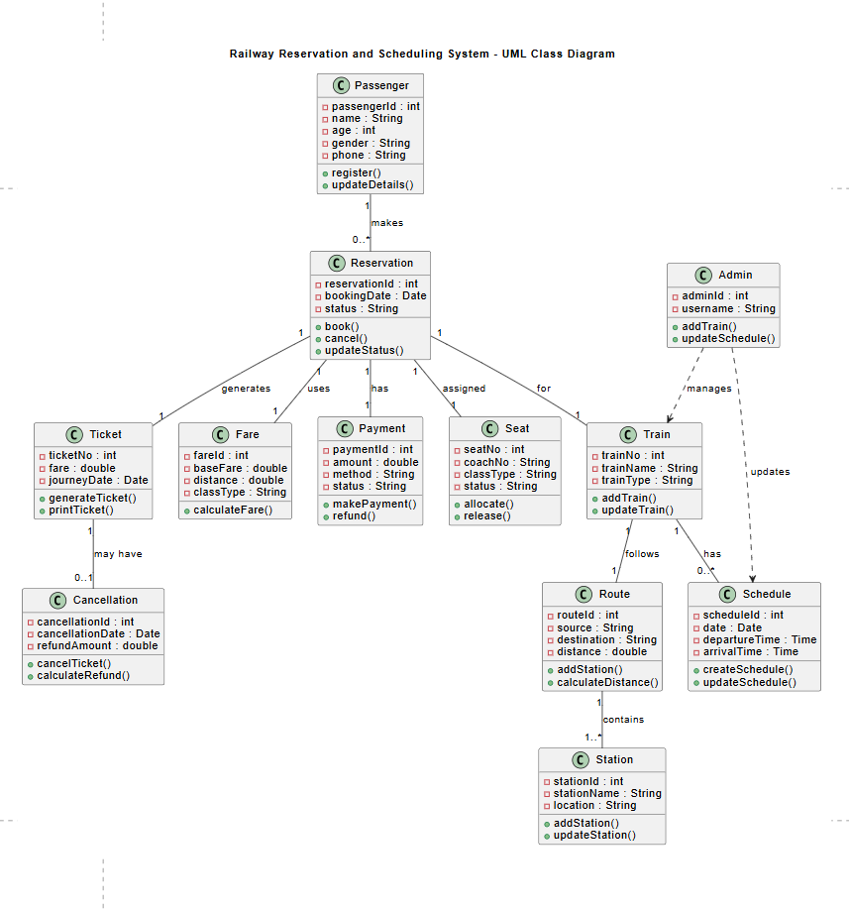

Layered Architecture
The redesigned system can use a four-layer architecture.
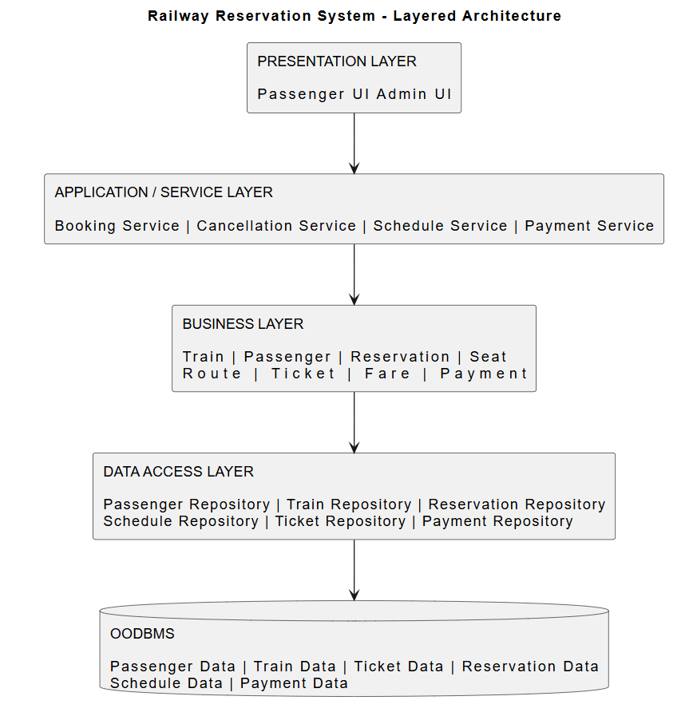
Presentation / View Layer
The Presentation Layer interacts with users.
Responsibilities:
- Display train schedules.
- Accept passenger information.
- Display available seats.
- Provide booking and cancellation options.
- Display ticket and reservation status.
- Show payment confirmation.
This layer does not contain complex business logic.

Application / Service Layer
The Application Layer coordinates different operations.
Important services include:
- BookingService
- CancellationService
- ScheduleService
- PassengerService
- PaymentService

For example, when a passenger books a ticket:
Passenger Request
↓
BookingService
↓
Check Schedule
↓
Check Seat Availability
↓
Calculate Fare
↓
Process Payment
↓
Create Reservation
↓
Generate Ticket
Business Layer
The Business Layer contains the main railway business rules.
It handles:
- Seat allocation rules.
- Fare calculation.
- Reservation status.
- Cancellation rules.
- Refund calculation.
- Train scheduling rules.
- Route and station validation.
Separating business rules from the user interface makes the system easier to modify.
For example, if railway fare rules change, only the Fare or FareCalculator component needs modification instead of changing the entire booking system.

Data Access Layer
The Data Access Layer communicates with the OODBMS.
Repositories can be created for:
- PassengerRepository
- TrainRepository
- ScheduleRepository
- ReservationRepository
- TicketRepository
- PaymentRepository
The business layer does not directly communicate with the database. This reduces dependency between business logic and database implementation.

OODBMS Integration
An Object-Oriented Database Management System can store objects directly.
Major persistent objects include:
- Passenger
- Train
- Schedule
- Route
- Station
- Seat
- Reservation
- Ticket
- Payment
- Cancellation
The Data Access Layer maps application objects to persistent objects in the OODBMS.
This provides better integration between object-oriented application classes and database objects.

Example Booking Flow
The redesigned booking process works as follows:
- Passenger enters source and destination.
- Presentation Layer sends the request to BookingService.
- BookingService requests available trains from ScheduleService.
- The selected train's seat availability is checked.
- FareCalculator calculates the fare.
- PaymentService processes the payment.
- Reservation object is created.
- The selected Seat is allocated.
- A Ticket object is generated.
- Reservation and ticket information are stored using repositories.
- Confirmation is displayed to the passenger.

Example Cancellation Flow
Passenger
↓
Cancellation Request
↓
CancellationService
↓
Find Reservation
↓
Validate Cancellation Rules
↓
Calculate Refund
↓
Update Reservation Status
↓
Release Seat
↓
Process Refund
↓
Display Cancellation Confirmation
This flow keeps cancellation logic independent from booking and scheduling modules.

How Cohesion is Improved
Cohesion refers to how closely related the responsibilities within a class or module are.
The redesigned system provides high cohesion because each class performs a focused responsibility.
For example:
- Passenger handles passenger information.
- Train handles train information.
- Seat handles seat allocation.
- Fare handles fare calculation.
- Payment handles payment processing.
- Reservation handles reservation details.
Therefore, unrelated responsibilities are not placed inside a single large class.

How Coupling is Reduced
Coupling refers to the dependency between different modules.
In the legacy system, booking, fare calculation, scheduling, payment, and database operations are tightly connected.
In the redesigned system:
Presentation
↓
Service
↓
Business
↓
Repository
↓
OODBMS
Each layer communicates through defined interfaces. Therefore, changes in one layer have minimal impact on other layers.
For example, changing the database technology does not require major changes to the Presentation Layer.

Scalability
The redesigned architecture supports scalability because individual components can be expanded independently.
For example:
- More trains can be added without changing the booking logic.
- New payment methods can be added through new payment implementations.
- New fare categories can be introduced using different fare calculators.
- More users can be supported by scaling the service layer.
- New interfaces such as mobile applications can use the same business services.

Maintainability
The system becomes easier to maintain because responsibilities are separated.
For example, if the railway authority changes the fare calculation rule:
Legacy System:
Fare Change
↓
Modify Booking
↓
Modify Ticket
↓
Modify Payment
↓
Modify Other Modules
Redesigned System:
Fare Rule Change
↓
FareCalculator
Only the required business component needs modification.

Advantages of the Redesigned System
Aspect | Legacy System | Redesigned System
Coupling | High | Low
Cohesion | Low | High
Maintainability | Difficult | Easy
Scalability | Limited | High
Reusability | Low | High
Test | Difficult | Easier
Business Logic | Mixed with other modules | Separated
Database Access | Direct/Tightly coupled | Repository-based
Modification | Affects many modules | Localized changes
Extensibility | Difficult | Easy

Reconstruction of the System
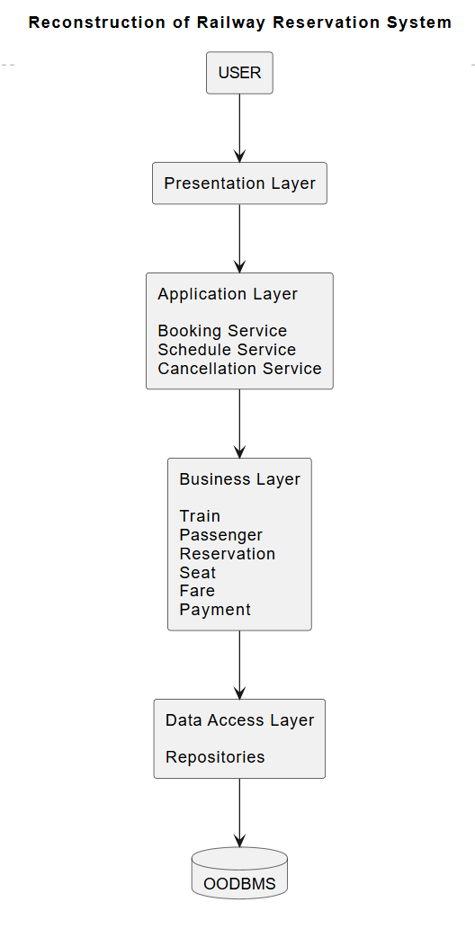
Conclusion
The reverse engineering of the Railway Reservation and Scheduling System identifies important classes such as Passenger, Train, Schedule, Route, Seat, Reservation, Ticket, Fare, Payment, and Cancellation. The redesigned system applies object-oriented principles such as encapsulation, abstraction, inheritance, polymorphism, and single responsibility.
The layered architecture separates the Presentation, Application, Business, Data Access, and OODBMS layers. This results in high cohesion and low coupling, making the system easier to test, modify, maintain, and scale. Changes in scheduling, fare calculation, payment, or database implementation can be handled independently without affecting the entire system. Therefore, the redesigned architecture provides a flexible and maintainable solution for a modern Railway Reservation and Scheduling System.

